Raising the Age of Criminal Responsibility

Purpose of report
For direction.
Summary
The age of criminal responsibility (ACR) refers to the minimum age that a child can be prosecuted and punished by law for an offence. England, Wales and Northern Ireland have one of the lowest ACRs in the world at age 10. Campaigners have been calling for the ACR to be raised to reflect international standards and research around child development. In May 2019, the Equalities and Human Rights Commission called on the Government to raise the ACR, noting that “criminalising children at such a young age can have a detrimental impact on their wellbeing and development and risks making them more likely to reoffend as adults.”
This paper brings further information to members, following the paper in December 2019, to ask members to agree an LGA position on raising the ACR.
Recommendation/s

Members are asked to consider whether the LGA’s position is that:
- we should stay at the current age of Criminal Responsibility
- increase the age to 12 in line with the Scottish Government or
- increase to 14, in line with the European average and the recommendations from the UN Convention on the Rights of the Child

Action/s
Officers will;
- undertake further research to know more about the children who are committing crimes
- continue to build up an understanding of best practice in this area to share with both Government and local authorities
- use the LGA’s agreed position in future work with the Government.

Contact officer: Flora Wilkie
Position: Adviser – Children and Young People
Email: flora.wilkie@local.gov.uk

Raising the Age of Criminal Responsibility
Background

- In January 2020 the Board discussed whether they wished the LGA to support calls to raise the Age of Criminal Responsibility (ACR).

- The age of criminal responsibility (ACR) refers to the minimum age that a child can be prosecuted and punished by law for an offence. In England, Wales and Northern Ireland, this is 10. In Scotland, the Age of Criminal Responsibility (Scotland) Act 2019 raised the ACR from 8 to 12.

- Although being broadly supportive of raising the minimum age, the Board requested further information and research before coming to a final position. Officers carried out further research and facilitated a roundtable of practitioners and experts to understand their experiences working with children who commit crime both below and above the age of criminal responsibility. This paper collates further information gathered and asks members of the Board whether the LGA wishes to support calls to raise the ACR and agrees to undertaking further work in this area.

Policy Context

- The United Nations Convention on the Rights of the Child, which was ratified by the UK government in 1991, calls upon states parties to establish a minimum age "below which children shall be presumed not to have the capacity to infringe the penal law". The UN Committee on the Rights of the Child recommended in 2007 that states set this minimum age at 12 or higher; in 2019, it revised this to a minimum age of at least 14.

- England currently has one of the lowest ACRs in the world:

Country | Age of Criminal Responsibility
Ireland | 12 (though children aged 10 or 11 can be held criminally liable for very serious crimes including murder and rape)
Germany | 14 (if ‘morally and mentally mature’ when the offence took place)
Sweden | 15
Italy | 14 (persons aged 14 to 17 (inclusive) can only be held criminally liable where they have been judged capable of forming the necessary criminal intent in relation to the specific offence)
Japan | 14
Australia | 10
China | 14
USA | In 33 states, there is no minimum age of criminal responsibility, according to the Child Rights International Network. In theory, that means a child of any age could be convicted and sentenced. Of the states that do have a minimum, North Carolina's is the lowest at seven years.

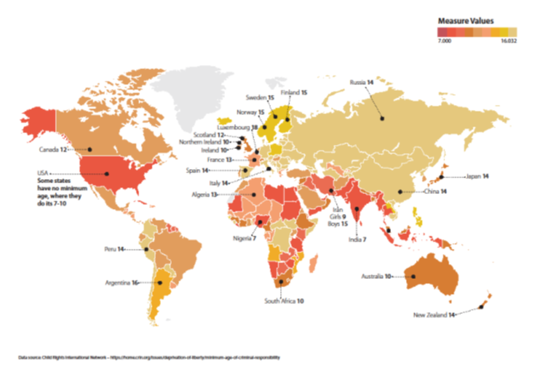
- A recent report published by the Justice Committee recommends a review into the ACR. A range of organisations have also called for all countries in the UK to increase the ACR, including the Association of Directors of Children’s Services, the Association of Youth Offending Team Managers and the Children’s Commissioner for England. Other organisations calling for the ACR to be raised include the Law Societies, the Royal Society, the Royal College of Psychiatrists and the All Party Parliamentary Group for Children.

- In May 2019, the Equalities and Human Rights Commission called on the Government to raise the ACR, noting that “criminalising children at such a young age can have a detrimental impact on their wellbeing and development and risks making them more likely to reoffend as adults.”

Demographics
- Demographics of children receiving a caution or sentence compared to the general 10-17 population, England and Wales, year ending March 2019:
 | 10-14 | 15-17+ | Boys | Girls
Children receiving a caution or sentence | 23% | 77% | 85% | 15%
10-17 population | 64% | 36% | 51% | 49%

- Children in the youth justice system who received a youth caution or sentence by age, year ending March 2019:

Age | 10 | 11 | 12 | 13 | 14 | 15 | 16 | 17+ |  | 10-14 total | 15-17+ total | Total
 | 32 | 141 | 568 | 1,371 | 2,777 | 4,241 | 5,367 | 7,168 |  | 4,889 | 16,776 | 21,665

- The proportion of Black children given a caution or sentence is almost three times higher than the proportion of Black children in the 10-17 population, and this has increased over the past 10 years.

- The proportion of more serious offences (for example, robbery and violent crime) was greater for those:
  - aged 15-17, (14% compared to 10% of offences committed by 10-14 year olds),
  - black children (23%, with other ethnic groups ranging from 11% to 22%), and
  - boys (15%, compared to 5% for girls).

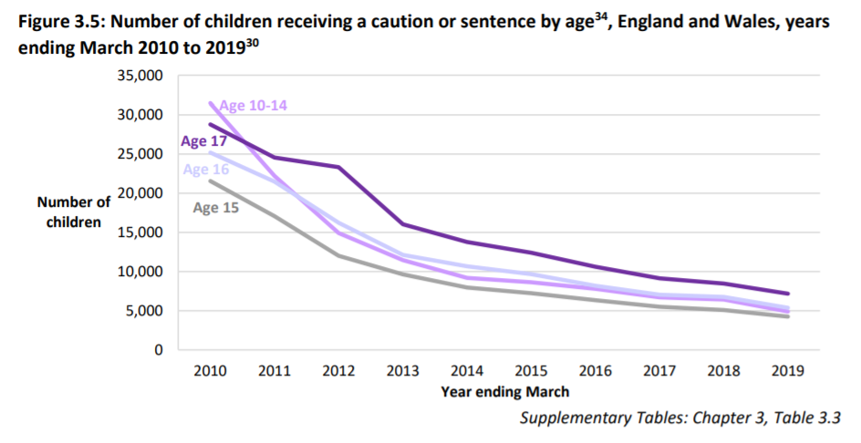
- There has been a significant reduction in the number of children receiving cautions or sentences over the past 10 years. This is seen across all age groups:
- The chart below shows the number of children in secure provision. The numbers of children below 14 are low, with a high of 28 in January last year.
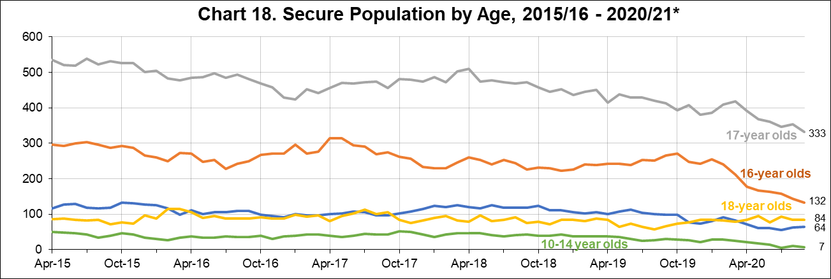

Child development
- There is a wealth of evidence that suggests that a 10-year-old’s brain is not developed with regards to both committing something that could be perceived as a criminal act, but also how to manage the experience in the criminal justice system.

- Evidence drawn from the House of Parliament, Age of Criminal Responsibility Briefing Paper (2018) highlights that brain imaging has shown that brain development, especially in the regions involved in decision-making, does not stop in childhood but continues into adulthood.

  - The prefrontal cortex (PFC) controls high-level cognitive and executive functions such as decision-making, planning, social interaction and inhibiting risk behaviours. It undergoes significant change during adolescence and is one of the last areas of the brain to reach full maturation.
  - The amygdala and the ventral striatum are associated with risk and reward. They undergo rapid development, thought to be triggered by puberty, and become hyper-responsive in adolescence.
  - The “dual systems” model proposes that the later development of the “control system” (PFC) compared to the “reward system” leads to a window of vulnerability to risk behaviours over which adolescents have less control than adults.
  - The white matter (connections between the different parts of the brain) also increase throughout adolescence and into the third or fourth decade of life. This is thought to represent a “speeding up” in the transmission of information throughout the brain.
  - The grey matter (synapses) increases in childhood before decreasing during adolescence (synaptic pruning), especially in the PFC. This is thought to represent “fine-tuning” of the brain according to the environment

- The difficulty in identifying an age at which children achieve these capacities is well recognised but 10 years has been considered too low by a range of professionals. In general research indicates that:

  - conventional morality, including “law and order” morality is generally not achieved until mid-teens.
  - logical thinking and problem solving abilities develop considerably between 11–15 years.
  - adolescent intellectual abilities are thought to reach adult levels only by the age of 17 years.
  - children who are abused or neglected are particularly poorly developed in the required capacities for criminal responsibility and are much more likely to come into conflict with the law.

- Children and adolescents are significantly less competent to participate (for example, to decide how to plead, instruct lawyers and respond to cross-examination) in criminal justice proceedings. They are more likely to make false confessions, and have limited capacity to understand and follow court processes as well as the significance of questions asked and answers given. Without competence, the likelihood of determining the truth and achieving justice is decreased.

The criminal justice system (CJS) process
- Board members requested further information about the process of the criminal justice system.

  - Children under 10 cannot be arrested or charged with a crime.
  - Children from 10 to 17 years old will be treated as ‘young offenders’ and all but the most serious criminal cases will be dealt with by the youth courts. If the child has committed an offence and an adult was also involved then the court proceedings can be held in either the magistrate’s or the Crown court.
  - Children under 10 who come to the attention of the police may be asked to attend a ‘safeguarding interview’ following consultation between the police and social services. The interview is designed to provide ‘words of advice’ to the parent and child regarding the child’s future conduct.
  - Secure Training Centres and Youth Offending Institutions only take offenders aged 12–18 and 15–21 respectively. Children under the age of 12 are be placed in secure children’s homes if in custody.

- Looking to the increase of children involved in child criminal exploitation such as county lines, protection is available under the Modern Slavery Act 2015. Section 45 of the Act created a defence for child victims who commit certain offences as a direct consequence of being a victim of slavery / exploitation. This requires a positive conclusive grounds decision through the National Referral Mechanism to confirm the child was a victim of modern slavery. The Home Office will shortly launch a pilot scheme to devolve NRM decision-making to local authorities to try to speed up decision making and improve outcomes for children.

Consequences of involvement in the CJS

- Evidence suggests that younger children have higher levels of re-offending and therefore repeated involvement in the CJS compared to children that have been involved in the CJS at a later age. The younger the child is when first having contact with juvenile justice, then the more likely it is the child will become entrenched in the justice system

- There is also a significant impact on the long term outcomes of children and young people. Involvement in the youth justice system reduces the likelihood that children will complete school and obtain educational qualifications. A criminal record also impacts directly on the chances of future employment. Children who have formal contact with the criminal justice system are less likely to be in work as young adults than those whose offending did not result in a formal sanction.
Interventions for children under the age of criminal responsibility
- Evidence suggests that countries with a low ACR, including England and Wales, have the highest rates of child detention in penal institutions and the poorest outcomes with regards to rehabilitation and reoffending. Involvement in the youth justice system has been linked to an increase the likelihood of offending. Robust welfare-based responses to the offending of less culpable children are therefore likely to be a more effective alternative to criminalisation, particularly as this cohort tends to have high welfare needs.

- In addition to enhanced social services involvement or education support and parental implications, there are two methods available to local partners to support children under ten (these are also available for children above the ACR):

- Local Child Curfew
  - The police can ban children from being in a public place between 9pm and 6am, unless accompanied by an adult. This is called a Local Child Curfew and can last for up to 90 days.
  - If a child breaks their curfew, they can be given a Child Safety Order.

- Child Safety Order

  - If a child has committed an offence or broken a Local Child Curfew, they can be placed under the supervision of a youth offending team. This is called a Child Safety Order.
  - The order normally lasts for up to 3 months, but in some cases it can last for up to 12 months.
  - If a child doesn’t stick to the rules of an order, the court can consider if the child should be taken into care.

- As you cannot commit a crime until you have reached the age of criminal responsibility the behaviour of concern would be addressed through other means such as parents and school or children's services. Raising the ACR would mean that children would be referred for help or intervention but without the need for criminal justice involvement or a criminal record. Children below the ACR whose behaviour results in grave harm can be supported in a secure children’s home under welfare legislation.

- A social care-based approach would ensure that the causes of behaviour were addressed, actions confronted and rehabilitation supported, without the associated long-term impacts of criminalisation. This could comprise support delivered by local partners (such as children’s services and voluntary sector organisations) as well as coercive welfare interventions (for example, parenting, supervision and care orders for more serious offenders).

- A challenge presented from the roundtable was that it can be challenging to engage children and parents in interventions when they are not enforced, however, there is a range of good practice that can be explored in this area and shared between local authorities.

- Practical interventions include:
  - Early intervention is seen as key to reducing child crime. Examples include parenting support, youth inclusion and Safer Schools programmes.
  - In Scotland, the Children’s Hearings System focuses on welfare interventions, although for serious crimes any child over the ACR is liable to criminal sanctions.
  - Welfare laws can be used in exceptional circumstances to deprive children of their liberty when there is a risk of harm to themselves or others. Half of children detained in SCHs are there on welfare grounds under s25 of the Children Act 1989.
  - Children with mental disorders and those found unfit to plead can be diverted from the CJS into mental health services.

- Social care teams already work to support children who have suffered neglect, abuse and adverse childhood experiences and considering that many children who are involved in the criminal justice system are likely to have experienced multiple disadvantages, these teams have the expertise to support them, though we must of course recognise the existing pressures on the system which must also be addressed.

- It is also essential to keep in mind the impact on the victim, or the victim’s family, depending on the seriousness of the actions and this was discussed at the roundtable. However, successful programmes such as restorative justice were referenced as more effective than a solely punitive approach.

The impact on local authorities

- The Board raised a concern that increasing the age of criminal responsibility may have an impact on the demands on local authorities. There would likely to additional pressure placed on children’s social care in order to provide early intervention and support to children but with the numbers of children being very small, this is unlikely to be so significant as to be unviable. In addition, the long-term outcomes for the child and reduced future involvement in services are likely to reduce long term social and financial costs.

- For those children in the youth custody system, the cost currently sits outside of the local authority so a redirection of this funding would have to be seen in support of any change to the ACR.

- The LGA could use any call for an increased age of ACR to also reiterate calls for greater funding in early intervention and social care services, to support children and divert them from the criminal justice system, and therefore improving their outcomes.

Feedback from partners

- In developing this response, officers spoke to a range of colleagues working within the system, such as the Youth Justice Board, National Youth Agency, Association of Youth Offending Team (YOTs) Managers and regional youth networks, to understand how this would impact their work.

- The general consensus was that on an individual local authority level, the numbers were so small that raising the ACR would have only a small impact. Furthermore, the anticipated positive impact on a child’s long-term outcomes could be significantly more beneficial than involving them in the criminal justice system.

“If a child's behaviour is repeatedly problematic to the extent that they are coming to police attention at the age of 10,11 or 12 then there is a problem which warrants proper intervention with home and school. Placing this in a criminal context would add nothing effective to the intervention and would likely familiarise the child to the criminal justice system sealing their trajectory”. Feedback from a youth justice colleague.

- Partners at the roundtable recognised that there would need to be a cultural shift across different agencies if the age was to be increased. Including adopting common language and approaches. There is some good practice that can be built on at the moment. For example, in Hampshire, if the police are called to a house where a child is present, they inform the school before 8am the next day so this can be picked up by the safeguarding lead. These sorts of actions and joined up working ensure support for the child is at the centre, reducing the likelihood of criminal activity by putting in place support when it is first needed.

- There is a range of well evaluated interventions outlined by the Early Intervention Foundation which are available to local authorities in supporting and deterring children and young people from offending.

Implications for Wales

- The age of criminal responsibility is set by section 50 of the Children and Young Persons Act 1933, which applies to both England and Wales. Any change to the ACR would affect both England and Wales. Officers will engage with the Welsh Local Government Association on this topic.

Financial Implications
- None.
Next steps
- Members’ decision on the LGA’s position on the ACR will enable officers to:
  - continue to build up an understanding of best practice in this area to share with both Government and local authorities
  - Undertake further research to know more about the children who are committing crime
  - use the LGA’s agreed position in future work with the Government.

https://www2.ohchr.org/english/bodies/crc/docs/CRC.C.GC.10.pdf
https://www.ohchr.org/Documents/HRBodies/CRC/GC24/GeneralComment24.pdf
https://committees.parliament.uk/committee/102/justice-committee/publications/
https://www.theguardian.com/society/2019/nov/04/age-of-criminal-responsibility-must-be-raised-say-experts
https://yjlc.uk/wp-content/uploads/2018/06/ACR.pdf
https://www.equalityhumanrights.com/en/our-work/news/government-must-improve-record-stopping-cruel-and-inhuman-treatment
file:///C:/Users/flora.wilkie/Downloads/POST-PN-0577.pdf
file:///C:/Users/flora.wilkie/Documents/Youth%20Justice/ACR/CSJ_Youth_Justice_Full_Report.pdf
https://www.cypp.unsw.edu.au/sites/ypp.unsw.edu.au/files/Cunneen%20%282017%29%20Arguments%20for%20raising%20the%20minimum%20age%20of%20criminal%20responsibility.pdf
https://thenayj.org.uk/wp-content/uploads/2015/06/2012-The-Age-of-Criminal-responsibility.pdf
https://yjlc.uk/wp-content/uploads/2018/06/ACR.pdf
https://guidebook.eif.org.uk/programme/multisystemic-therapy#about-the-programme

